
Family Violence Program Management
FVNet File Upload Data Format Guide

March 26, 2025
HHSC - IT Social Services Applications

Table of Contents
1. Overview 2
2. File Naming Convention 3
3. Client Level Information 4
3.1 Client Demographic Information 4
3.2 Victimization Information 5
3.3 Client Services 6
3.4 Client Assistance 7
4. Site Level Information 8
4.1 Aggregate Client County Information 8
4.2 Aggregate Client Language Information 9
4.3 Education Presentation 10
4.4 Hotline Calls 11
4.5 Aggregate Data 12
4.6 Surveys 12
4.7 Referral Data 13
5. HHSC Type Setup 14
5.1 FVNet HHSC Type Setup 14
5.2 Support for Multiple Shelters and Hotel Stays 15
6. Additional Validations 15
6.1 SITE / Contract / HHSC Types Validation 15
6.2 TANF Date Validation 15
7. Lookup Tables 16
7.1 AGE_STATUS 16
7.2 RACE_ETHNICITY 16
7.3 MILITARY_STATUS 16
7.4 SEX 16
7.5 TANF_STATUS 16
7.6 ABUSE_TYPE 16
7.7 YOUTH_IPV_STATUS 17
7.8 ABUSER_RELATIONSHIP 17
7.9 SERVICE_TYPE 17
7.10 HHSC_TYPE 18
7.11 SERVICE_CHANNEL 18
7.12 CLIENT_ASSISTANCE 18
7.13 LANGUAGE 18
7.14 EDUCATION_TYPE 19
7.15 CALL_TYPE 19
7.16 SURVEY_TYPE 20
7.17 REFERRAL_TYPE 20
7.18 COUNTY 21

Overview
This document describes the data elements and file format for the 11 csv files exported from provider tool and then uploaded into HHSC FVNET website.
- File Naming Convention - Defines the naming convention for the files uploaded by FV providers.
- Client Level Information
  - Client Demographic Information
  - Victimization Information
  - Client Services
  - Client Assistance
- Site Level Information
  - Aggregate New Client County Information
  - Aggregate New Client Language Information
  - Education Presentations
  - Hotline Calls
  - Aggregate Data
  - Performance Outcome Survey Data
  - Referral Data
The sections below define the categories in more detail and the order and data elements for each category.

File Naming Convention
File naming convention is defined to identify uniquely by provider name and reporting month. There are 11 different categories of data collected in 11 separate CSV files. File name consists of 3 parts separated by underscore.
File Format:
- YYYYMM_SITESHORTNAME_CLIENT.csv
- YYYYMM_SITESHORTNAME_VICTIMIZATION.csv
- YYYYMM_SITESHORTNAME_CLIENT_SERVICES.csv
- YYYYMM_SITESHORTNAME_CLIENT_SERVED_BY_COUNTY.csv
- YYYYMM_SITESHORTNAME_CLIENT_SERVED_BY_LANGUAGE.csv
- YYYYMM_SITESHORTNAME_EDUCATION_PRESENTATION.csv
- YYYYMM_SITESHORTNAME_HOTLINE_CALLS.csv
- YYYYMM_SITESHORTNAME_SURVEY.csv
- YYYYMM_SITESHORTNAME_AGGREGATE_DATA.csv
- YYYYMM_SITESHORTNAME_CLIENT_ASSISTANCE.csv
- YYYYMM_SITESHORTNAME_REFERRAL_DATA.csv
Part 1 | Month and Year of the data reported.  Year is 4 digits  Month should always be 2 digits. For Example, January should be entered as ‘01’
Part 2 | Site short name of the reporting site. All upper case
Part 3 | Name of Data Set. All upper case
File names are case sensitive. All letters should be in upper case.
Example File Names for SafePlace:
- 202501_AU1_CLIENT.csv
- 202501_AU1_VICTIMIZATION.csv
- 202501_AU1_CLIENT_SERVICES.csv
- 202501_AU1_CLIENT_SERVED_BY_COUNTY.csv
- 202501_AU1_CLIENT_SERVED_BY_LANGUAGE.csv
- 202501_AU1_EDUCATION_PRESENTATION.csv
- 202501_AU1_HOTLINE_CALLS.csv
- 202501_AU1_SURVEY.csv
- 202501_AU1_AGGREGATE_DATA.csv
- 202501_AU1_CLIENT_ASSISTANCE.csv
- 202501_AU1_REFERRAL_DATA.csv
Note: ‘AU1’ is the SITE Short Name for SafePlace

Client Level Information

Client Demographic Information
Data Element | Description | Required? | Possible Values | Validation
Client_Id | This is unique client id for the specific SITE  ID is assigned to the client by the provider. | Y | Examples:  80923  Abc234566  Spabggj23-2424 | Client Id allowed characters are alphanumeric and dashes (-).  This field is optional for SNRP and/or EIF contracts that do not provide direct services.
Age | Specific age at the last day of the reporting month. | N | Number | If a value is provided, it should be greater than or equal to zero. If age is below one, age is zero.  This field is optional for SNRP or EIF contracts that do not provide direct services.
Age_Status | If age is missing, provide the Age Status. | Conditionally mandatory | Lookup Table  AGE_STATUS | If age is not provided, then Age Status is mandatory.  This field is optional for SNRP or EIF contracts that do not provide direct services.
Race_Ethnicity | This is the race and/or ethnicity of the client.  Multiple values are possible. | Y | Lookup Table  RACE_ETHINICITY | These fields are optional for SNRP or EIF contracts that do not provide direct services.
Military_Status | Does the client have military experience? | Y | Lookup Table  MILITARY_STATUS
Sex | This is the sex of the client. | Y | Lookup Table  SEX
TANF_Date_Completed | Date TANF form was completed. | N | Date | Date format can be M/D/YYYY or MM/DD/YYYY  TANF form is required for Shelter and Nonresidential clients. These fields are optional for SNRP or EIF contracts.  See Validation for TANF Date for more information
TANF_Status | This is the status of the TANF. | N | Lookup Table  TANF_STATUS
Total_Shelter_Days | This is the number of days the client stayed in shelter. | Y | Number | Shelter days include the day they enter the “enter shelter” and “exit shelter” service. Example: If a client enters today and exits tomorrow, it counts as two days.  This field should be 0 for all nonresidential clients.
- Sites should provide client data for the below scenarios only:
  - If at least one service is provided for that month;
  - If victimization is reported for that month;
  - If shelter days were provided for that month; or
  - If client assistance type was provided for that month.
- If the Data Element has a lookup table listed under ‘Possible Values’ column in the above table, then the code should be provided in the file.
Sample Data
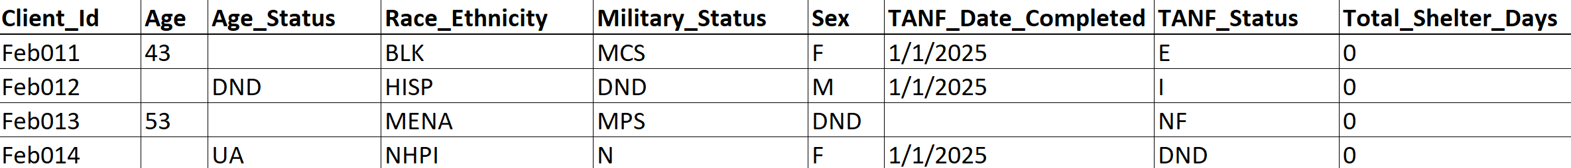

Victimization Information
Data Element | Description | Required? | Possible Values | Validation
Client_Id | This is unique client id for the specific SITE  ID is assigned to the client by the provider. | Y | Examples:  80923  Abc234566  Spabggj23-2424 | Client Id allowed characters are alphanumeric and dashes (-).  This field is optional for SNRP or EIF contracts that do not provide direct services.
Type_of_Abuse | Type of abuse experienced. Multiple values are possible. | Y | Lookup Table  ABUSE_TYPE | These fields are optional for SNRP or EIF contracts that do not provide direct services.  If providing victimization information, all fields are mandatory.
Youth_IPV_Victim_Status | Is client Youth IPV Victim? | Y | Lookup Table  YOUTH_IPV_STATUS
Victim_Abuser_Relationship | This is the Offender/abuser’s relationship to the victim. | Y | Lookup Table  ABUSER_RELATIONSHIP
- Sites will provide one victimization record per client if available.
- When a victimization is reported then it must have an accompanying record in the services file.
- HHSC would expect to have a victimization reported for each fiscal year, meaning if a client came for services in August and reported a victimization then that record would need to come over again in September for the new fiscal year assuming client is still getting services.
- If the Data Element has a lookup table listed under ‘Possible Values’ column in the above table, then the code should be provided in the file.
Sample Data
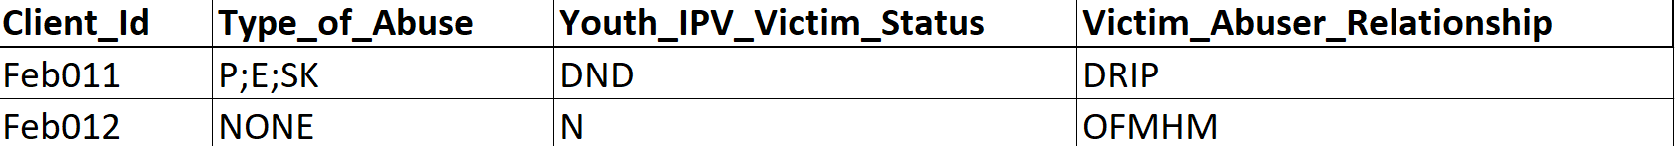

Client Services
Data Element | Description | Required? | Possible Values | Validation
Client_Id | This is unique client id for the specific SITE  ID is assigned to the client by the provider. | Y | Examples:  80923  Abc234566  Spabggj23-2424 | Client Id allowed characters are alphanumeric and dashes (-).  Date format can be M/D/YYYY or MM/DD/YYYY  These fields are optional for SNRP or EIF contracts that do not provide direct services.  All data elements are required for file to be accepted for those sites reporting client services.  See validation section for additional rules.
Service_Type | This is the type of service provided. | Y | Lookup Table  SERVICE_TYPE
In_Shelter | Is the client staying in shelter or not? (Renamed from “Is_Residence”) | Y | Y or N
HHSC_Type | HHSC type is the source of funding or location provided for the service. See Data and Reporting Guide for more information. (Renamed from “Funding Source”) | Y | Lookup Table  HHSC_TYPE
Total_Service_Contacts | Number of service contacts for the same service type, day, service channel and HHSC type. | Y | Number
Service_Date | Date the service was provided. | Y | Date
Service_County | County in which the service was provided. | Y | Lookup Table  COUNTY
Service_Channel | How was the service provided? | Y | Lookup Table  SERVICE_CHANNEL
- There will be separate rows for each service type provided to a client. If the same service type is provided to the client on the same day, through the same channel and under the same HHSC type, it should appear in a single row with the ‘Total Service Contacts’ with the number of times that service type was provided on the same day, through the same channel and under the same HHSC type.
- All service types are allowable by all service channels except for “Enter Shelter” and “Exit Shelter” which must be provided Face to Face.
- If a client has a service, their information should also show up in Client.csv.
- If the Data Element has a lookup table listed under ‘Possible Values’ column in the above table, then the code should be provided in the file.

Sample Data
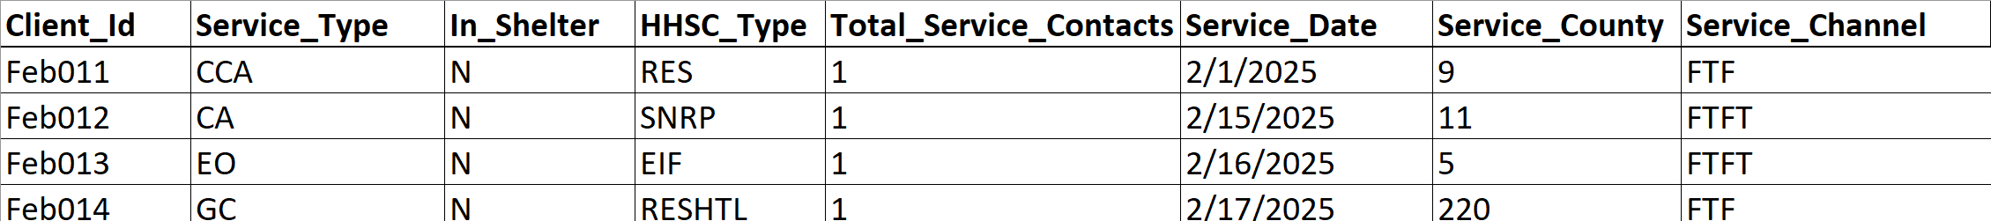

Client Assistance
Data Element | Description | Required? | Possible Values | Validation
Client_Id | This is unique client id for the specific SITE.  ID is assigned to the client by provider. | Y | Examples:  80923  Abc234566  Spabggj23-2424 | Client Id allowed characters are alphanumeric and dashes (-).  These fields are optional for SNRP or EIF contracts that do not provide direct services.  Date format can be M/D/YYYY or MM/DD/YYYY  All data elements are required for the file to be accepted for those reporting Client Assistance.
HHSC_Type | HHSC type is the source of funding or location provided for the assistance. See Data and Reporting Guide for more information. (Renamed from “Funding Source”) | Y | Lookup Table  HHSC_TYPE
Client_Assistance_Type | Type of assistance provided for the client. | Y | Lookup Table  CLIENT_ASSISTANCE
Assistance_Date | Date of which assistance is provided. | Y | Date
- If a client is in the Client_Assistance.csv, they should also appear in the Client.csv.
- If the Data Element has a lookup table listed under ‘Possible Values’ column in the above table, then the code should be provided in the file.
Sample Data
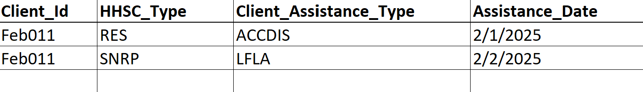

Site Level Information

Aggregate Client County Information
Data Element | Description | Required? | Possible Values | Validation
County_Of_Residence | This is the county of residence of new clients served. | Y | Lookup Table  COUNTY | All data elements are required for the file to be accepted if the site is reporting data in this table. These fields are optional for SNRP or EIF contracts that do not provide direct services.
Total_New_Clients_Served | A unique number of new clients served within the reporting year (state FY), e.g., all current clients are considered "new" in the first month of the reporting year. After the first month, only the new clients are included as new in each subsequent month

- This is the aggregate of only new clients served by county in that reported month.
- Only the counties of residence of new clients served in the reporting month need to be included in the .csv file.
- If Data Element has a lookup table listed under ‘Possible Values’ column in the above table, then the code should be provided in the file.
Sample Data
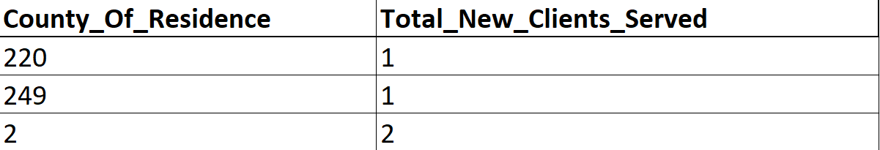

Aggregate Client Language Information
Data Element | Description | Required? | Possible Values | Validation
Preferred_Language | This is the preferred language of new clients served. | Y | Lookup Table  LANGUAGE | All data elements are required for the file to be accepted if the site is reporting data in this table. These fields are optional for SNRP or EIF contracts that do not provide direct services.
Total_New_Clients_Served | A unique number of new clients served within the reporting year (state FY), e.g., all current clients are considered "new" in the first month of the reporting year. After the first month, only the new clients are included as new in each subsequent month. | Y | Number
- This is the aggregate of only new clients served by language in the reporting month.
- Only the preferred languages of new clients served in the reporting month need to be included in the .csv file.
- If Data Element has a lookup table listed under ‘Possible Values’ column in the above table, then the code should be provided in the file.
Sample Data
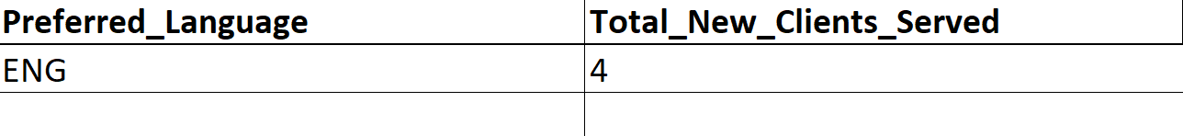

Education Presentation
Data Element | Description | Required? | Possible Values | Validation
Education_Type | This is the type of education provided. | Y | Lookup Table  EDUCATION_TYPE | All data elements are required for the file to be accepted.  Total Youth and Adult attendance count can be an estimate.  Make sure the attendance count is for that session or all sessions.
HHSC_Type | HHSC type is the source of funding or location provided for educational services. (Renamed from “Funding Source”) | Y | Lookup Table  HHSC_TYPE
Total_Adult_Attendance | Number of adult participants by Education Type | Y | Number
Total_Youth_Attendance | Number of youth participants by Education Type | Y | Number
Event_County | County where event was held | Y | Lookup Table  COUNTY
No_Of_Sessions | Number if sessions conducted by Education Type | Y | Number

- Multiple rows are allowed for the same education types.
- If the Data Element has a lookup table listed under ‘Possible Values’ column in the above table, then the code should be provided in the file.
Sample Data

Hotline Calls
Data Element | Description | Required? | Possible Values | Validation
Hotline_Call_Topics | This is the unduplicated number of hotline calls and hotline call topics for the reporting month.  The first two rows are the unduplicated number of hotline contacts (UHCALL_COUNT and UHVCON_COUNT).  Each row below are the hotline call topics discussed during the unduplicated hotline contacts. | Y | Lookup Table  CALL_TYPE | All ‘Hotline_Call_Topics’ values should be entered in the file even if Total_Calls value is 0.  The sum of UHCALL_COUNT and UHVCON_COUNT should equal your total number of hotline contacts.  Each Hotline Call Topic (except UHCALL_COUNT and UHVCON_COUNT) should not exceed the Sum of UHCALL_COUNT and UHVCON_COUNT.  Sum of all Hotline Call Topics (except UHCALL_COUNT and UHVCON_COUNT) should be equal to or more than the sum of UHCALL_COUNT and UHVCON_COUNT.
- If the Data Element has a lookup table listed under ‘Possible Values’ column in the above table, then the code should be provided in the file
Sample Data
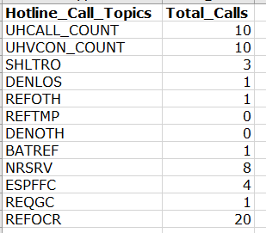

Aggregate Data
Data Element | Description | Required? | Possible Values | Validation
DISABILITY_COUNT | Number of clients self-identified as having a disability and needing accommodation to access shelter or services. | Y | Number | Client information should only be reported once per client in the fiscal year.  If there is no data to report, the numbers in this table should be zero.
LGBTQ_COUNT | Number of clients self-identified as LGBTQ. | Y | Number
LANGSVCS_COUNT | Number of clients needing language services such as interpretation. | Y | Number
Sample Data
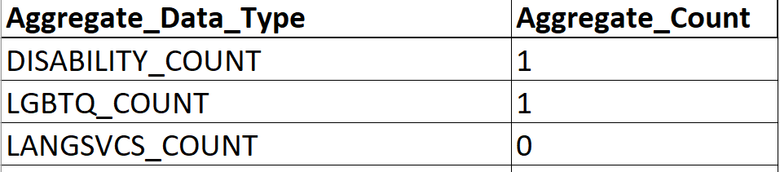

Surveys
Data Element | Description | Required? | Possible Values | Validation
Survey_Type | This is the type of survey. | Y | Lookup Table  SURVEY_TYPE | If there is no data to report, the numbers in this table should be 0 rather than being blank.
No_Of_Surveys_Comp_Res_Outcome | Number of Surveys completed for Resource Outcome | Y | Number
Yes_Resource_Outcome | Number of YES responses to Resource Outcome | Y | Number
No_Of_Surveys_Comp_Safety_Outcome | Number of Surveys completed for Safety Outcome | Y | Number
Yes_Safety_Outcome | Number of YES responses to Safety Outcome | Y | Number

- If Data Element has lookup table listed under ‘Possible Values’ column in the above table, then the code should be provided in the file.
Sample Data
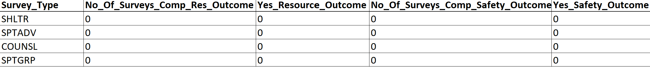

Referral Data
Data Element | Description | Required? | Possible Values | Validation
Referral_Type | This is an aggregate count of this Referral Type in the reporting month. It is not tied to any client ID. | Y | Lookup Table  REFERRAL_TYPE | If there is no data to report, the numbers in this table should be 0 rather than being blank.
Referral_Count | Number of Referral Type count. | Y | Number
Sample Data
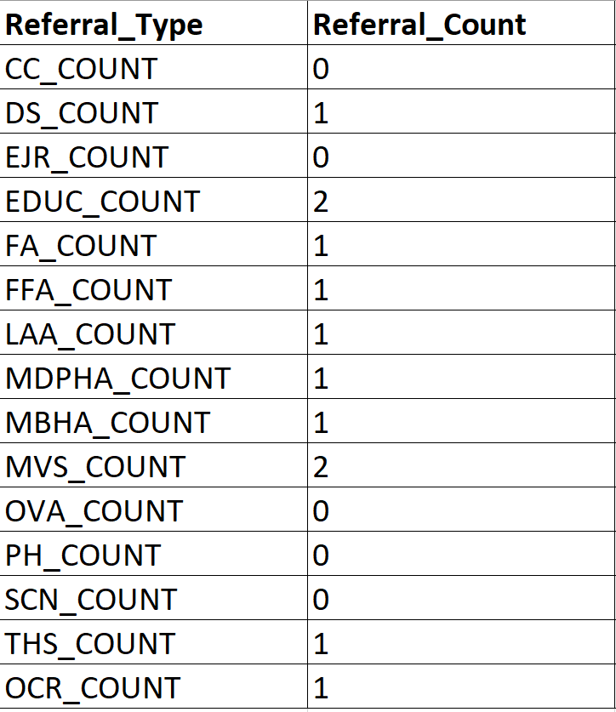

HHSC Type Setup

FVNet HHSC Type Setup
HHSC Family Violence Program (FVP) will ensure that all grantees will have the correct HHSC Types associated with the grantee contract(s) with start and end dates set up in FVNet to allow for accurate upload of information. See the Data and Reporting Guide for more information about HHSC Types.
Sample Contract Setup in FVNet (assigned by FVP)
Shelter Contract
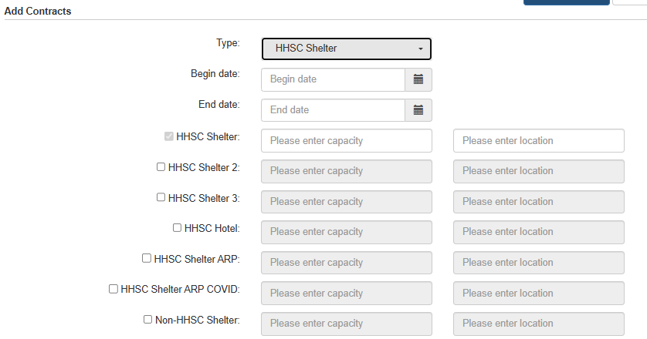
Nonresidential Contract
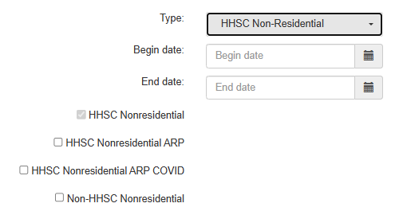

Support for Multiple Shelters and Hotel Stays
FVNET system supports data from multiple shelter locations in a single upload. There are changes to the .csv files formats and as well as the addition of new HHSC Types (previously known as Funding Sources). Below is a summary of the newly added and renamed HHSC Types and Non-HHSC Types:
HHSC Types
- Main location: HHSC Shelter (RES)
- Additional location: HHSC Shelter 2 (RES2) (previously HHSC Shelter A (RESA))
- Third additional location: HHSC Shelter 3 (RES3) (previously HHSC Satellite (SLITE))
- Clients staying in Hotels, Motels, or Safe Homes: HHSC Hotel (RESHTL)
- Clients staying in a shelter not funded by HHSC: Non-HHSC Shelter (NHRES)

Additional Validations

SITE / Contract / HHSC Types Validation
SITE should provide valid HHSC Type code in the files as per the contract and set-up in FVNet by FVP
Examples:
Site Short Name | Site Full Name | HHSC Type Code | HHSC Type Desc
AU1 | Travis County Domestic Violence/Sexual Assault Center | RES | HHSC Shelter
AU1 | Travis County Domestic Violence/Sexual Assault Center | SNRP | HHSC SNRP
ELD | Eastland County Crisis Center, Inc | NONRES | HHSC Non-Residential

TANF Date Validation
TANF_STATUS Code | Description | Validation for TANF_DATE
E | Eligible | Date is required; it should be the date form was completed
I | Ineligible | Date is required; it should be the date form was completed
NF | No Form on File | No date is required
DND | Did Not Disclose | Date is required. It should be the date the client refused to complete the form.

Lookup Tables

AGE_STATUS
Code | Description
UA | Unknown Adult
UC | Unknown Child
DND | Did Not Disclose

RACE_ETHNICITY
Code | Description
BLK | Black or African American
AIAN | American Indian or Alaskan Native
ASN | Asian
HISP | Hispanic or Latino
MENA | Middle Eastern or North African
NHPI | Native Hawaiian or Pacific Islander
WHT | White
O | Other
DND | Did Not Disclose

MILITARY_STATUS
Code | Description
MCS | Current Service
MPS | Prior Service
N | No
DND | Did Not Disclose

SEX
Code | Description
F | Female
M | Male
DND | Did Not Disclose

TANF_STATUS
Code | Description
E | Eligible
I | Ineligible
NF | No Form on File
DND | Did Not Disclose

ABUSE_TYPE
Code | Description
P | Physical
E | Emotional/Psychological/Verbal
SK | Stalking
SX | Sexual
HT | Human Trafficking
EF | Economic/Financial
NONE | None
DND | Did Not Disclose

YOUTH_IPV_STATUS
Code | Description
Y | Yes
N | No
DND | Did Not Disclose

ABUSER_RELATIONSHIP
Code | Description
S | Spouse (Current or Former)
DRIP | Dating Relationship or Intimate Partner (Current or Former)
OFMHM | Other Family Member or Household Member
DND | Did Not Disclose

SERVICE_TYPE
Code | Description
CCA | Childcare or Childcare Assistance
CAAS | Children's Advocacy and Services
CA | Client Assistance
CT | Counseling/Therapy
CI | Crisis Intervention
EHA | Economic/Housing Advocacy
EO | Emergency Orientation
ENTER | Enter Shelter
EXIT | Exit Shelter
GA | General Advocacy
GC | Good Cause
HA | Health Advocacy
LAA | Legal Advocacy and Accompaniment
LR | Legal Representation
MA | Medical Accompaniment
NA | Needs Assessment
ORIENT | Orientation
PSS | Peer Support Services
RCS | Referral - Community Services
SP | Safety Planning
SGRP | Support Groups
TR | Transportation

HHSC_TYPE
Code | Description
RES | HHSC Shelter
RES2 | HHSC Shelter 2
RES3 | HHSC Shelter 3
RESHTL | HHSC Hotel
NHRES | Non-HHSC Shelter
NONRES | HHSC Nonresidential
NHNR | Non-HHSC Nonresidential
SNRP | HHSC SNRP
EIF | HHSC EIF
SNRARP | HHSC SNRP American Rescue Plan (ends 9/30/2025)

SERVICE_CHANNEL
Code | Description
FTF | Face to Face
FTFT | Face to Face Technology
TEL | Telephone
WRITE | Written

CLIENT_ASSISTANCE
Code | Description
ACCDIS | Accommodations for Survivors with Disabilities
AEEE | Adult Education and Employment Expenses
CCRE | Childcare and Child-Related Expenses
HSRA | Home, Security, and Relocation Assistance
IDVDR | ID/Vital Document Replacement
LFLA | Legal Fees and Legal Assistance
PMHE | Physical/Mental Health Expenses
RMP | Rent and Mortgage Payments
UTIL | Utilities
VRE | Vehicle-Related Expenses
OTH | Other

LANGUAGE
Code | Description
ENG | English
SPA | Spanish
ASL | American Sign Language
VIET | Vietnamese
CANT | Cantonese
URDU | Urdu
KOR | Korean
ARAB | Arabic
CHIN | Chinese
FRE | French
TAGA | Tagalog
GER | German
ITL | Italian
RUS | Russian
O | Other
AMH | Amharic
BUR | Burmese
FAR | Farsi
HIN | Hindi
JPN | Japanese
NEP | Nepali
THAI | Thai

EDUCATION_TYPE
Code | Description
CE | Community Education
PREVEN | Prevention

CALL_TYPE
Code | Description
UHCALL_COUNT | Unduplicated Hotline Calls
UHVCON_COUNT | Unduplicated Hotline Virtual Contacts
SHLTRO | Seeking Shelter - Shelter Obtained
DENLOS | Seeking Shelter - DENLOS
REFOTH | Seeking Shelter - Referral to Another FV Shelter
REFTMP | Seeking Shelter - Referral to Temporary Shelter
DENOTH | Seeking Shelter - Denied for Other Reasons
BATREF | Batterer/Offender Referral
NRSRV | Seeking Nonresidential Services
ESPFFC | Family Violence Education, Safety Planning, or Family and Friends Call
REQGC | Requesting Good Cause
REFOCR | Referral to Other Community Resources

SURVEY_TYPE
Code | Description
SHLTR | Shelter Survey
SPTADV | Support Services and Advocacy Survey
COUNSL | Counseling Survey
SPTGRP | Support Group Survey

REFERRAL_TYPE
Code | Description
CC_COUNT | Child Care
DS_COUNT | Disability Services
EJR_COUNT | Employment and Job Readiness
EDUC_COUNT | Educational
FA_COUNT | Financial Assistance
FFA_COUNT | Food or Food Assistance
LAA_COUNT | Legal Aid and Assistance
MDPHA_COUNT | Medical/Dental/Physical Health Assistance
MBHA_COUNT | Mental and Behavioral Health Assistance
MVS_COUNT | Military/Veteran Services
OVA_COUNT | Other Victim Assistance
PH_COUNT | Housing
SCN_COUNT | Support for Children's Needs
THS_COUNT | Temporary Housing/Shelter
OCR_COUNT | Other Community Resource

COUNTY

Code | Description
1 | ANDERSON
2 | ANDREWS
3 | ANGELINA
4 | ARANSAS
5 | ARCHER
6 | ARMSTRONG
7 | ATASCOSA
8 | AUSTIN
9 | BAILEY
10 | BANDERA
11 | BASTROP
12 | BAYLOR
13 | BEE
14 | BELL
15 | BEXAR
16 | BLANCO
17 | BORDEN
18 | BOSQUE
19 | BOWIE
20 | BRAZORIA
21 | BRAZOS
22 | BREWSTER
23 | BRISCOE
24 | BROOKS
25 | BROWN
26 | BURLESON
27 | BURNET
28 | CALDWELL
29 | CALHOUN
30 | CALLAHAN
31 | CAMERON
32 | CAMP
33 | CARSON
34 | CASS
35 | CASTRO
36 | CHAMBERS
37 | CHEROKEE
38 | CHILDRESS
39 | CLAY
40 | COCHRAN
41 | COKE
42 | COLEMAN
43 | COLLIN
44 | COLLINGSWORTH
45 | COLORADO
46 | COMAL
47 | COMANCHE
48 | CONCHO
49 | COOKE
50 | CORYELL
51 | COTTLE
52 | CRANE
53 | CROCKETT
54 | CROSBY
55 | CULBERSON
56 | DALLAM
57 | DALLAS
58 | DAWSON
59 | DEAF SMITH
60 | DELTA
61 | DENTON
62 | DEWITT
63 | DICKENS
64 | DIMMIT
65 | DONLEY
66 | DUVAL
67 | EASTLAND
68 | ECTOR
69 | EDWARDS
70 | ELLIS
71 | EL PASO
72 | ERATH
73 | FALLS
74 | FANNIN
75 | FAYETTE
76 | FISHER
77 | FLOYD
78 | FOARD
79 | FORT BEND
80 | FRANKLIN
81 | FREESTONE
82 | FRIO
83 | GAINES
84 | GALVESTON
85 | GARZA
86 | GILLESPIE
87 | GLASSCOCK
88 | GOLIAD
89 | GONZALES
90 | GRAY
91 | GRAYSON
92 | GREGG
93 | GRIMES
94 | GUADALUPE
95 | HALE
96 | HALL
97 | HAMILTON
98 | HANSFORD
99 | HARDEMAN
100 | HARDIN
101 | HARRIS
102 | HARRISON
103 | HARTLEY
104 | HASKELL
105 | HAYS
106 | HEMPHILL
107 | HENDERSON
108 | HIDALGO
109 | HILL
110 | HOCKLEY
111 | HOOD
112 | HOPKINS
113 | HOUSTON
114 | HOWARD
115 | HUDSPETH
116 | HUNT
117 | HUTCHINSON
118 | IRION
119 | JACK
120 | JACKSON
121 | JASPER
122 | JEFF DAVIS
123 | JEFFERSON
124 | JIM HOGG
125 | JIM WELLS
126 | JOHNSON
127 | JONES
128 | KARNES
129 | KAUFMAN
130 | KENDALL
131 | KENEDY
132 | KENT
133 | KERR
134 | KIMBLE
135 | KING
136 | KINNEY
137 | KLEBERG
138 | KNOX
139 | LAMAR
140 | LAMB
141 | LAMPASAS
142 | LA SALLE
143 | LAVACA
144 | LEE
145 | LEON
146 | LIBERTY
147 | LIMESTONE
148 | LIPSCOMB
149 | LIVE OAK
150 | LLANO
151 | LOVING
152 | LUBBOCK
153 | LYNN
154 | MADISON
155 | MARION
156 | MARTIN
157 | MASON
158 | MATAGORDA
159 | MAVERICK
160 | MCCULLOCH
161 | MCLENNAN
162 | MCMULLEN
163 | MEDINA
164 | MENARD
165 | MIDLAND
166 | MILAM
167 | MILLS
168 | MITCHELL
169 | MONTAGUE
170 | MONTGOMERY
171 | MOORE
172 | MORRIS
173 | MOTLEY
174 | NACOGDOCHES
175 | NAVARRO
176 | NEWTON
177 | NOLAN
178 | NUECES
179 | OCHILTREE
180 | OLDHAM
181 | ORANGE
182 | PALO PINTO
183 | PANOLA
184 | PARKER
185 | PARMER
186 | PECOS
187 | POLK
188 | POTTER
189 | PRESIDIO
190 | RAINS
191 | RANDALL
192 | REAGAN
193 | REAL
194 | RED RIVER
195 | REEVES
196 | REFUGIO
197 | ROBERTS
198 | ROBERTSON
199 | ROCKWALL
200 | RUNNELS
201 | RUSK
202 | SABINE
203 | SAN AUGUSTINE
204 | SAN JACINTO
205 | SAN PATRICIO
206 | SAN SABA
207 | SCHLEICHER
208 | SCURRY
209 | SHACKELFORD
210 | SHELBY
211 | SHERMAN
212 | SMITH
213 | SOMERVELL
214 | STARR
215 | STEPHENS
216 | STERLING
217 | STONEWALL
218 | SUTTON
219 | SWISHER
220 | TARRANT
221 | TAYLOR
222 | TERRELL
223 | TERRY
224 | THROCKMORTON
225 | TITUS
226 | TOM GREEN
227 | TRAVIS
228 | TRINITY
229 | TYLER
230 | UPSHUR
231 | UPTON
232 | UVALDE
233 | VAL VERDE
234 | VAN ZANDT
235 | VICTORIA
236 | WALKER
237 | WALLER
238 | WARD
239 | WASHINGTON
240 | WEBB
241 | WHARTON
242 | WHEELER
243 | WICHITA
244 | WILBARGER
245 | WILLACY
246 | WILLIAMSON
247 | WILSON
248 | WINKLER
249 | WISE
250 | WOOD
251 | YOAKUM
252 | YOUNG
253 | ZAPATA
254 | ZAVALA
OS | Out of State
OC | Out of Country
DND | Did Not Disclose

